**Name**-Prachi Kashyap

**Course**-BCA **Semester**-5

**Section**-B

**Roll No.(University)**-1921117

**Subject**-Mobile Application Development

## Problem Statement- Create a simple application to implement a simple calculator in android.

## Objective -To be able to perform arithmetic operations using calculator.

**Source Code:**

**activity_main.xml-**

<?xml version="1.0" encoding="utf-8"?>  
<RelativeLayout xmlns:android="http://schemas.android.com/apk/res/android"  
 xmlns:app="http://schemas.android.com/apk/res-auto"  
 xmlns:tools="http://schemas.android.com/tools"  
 android:layout_width="match_parent"  
 android:layout_height="match_parent"  
 tools:context=".MainActivity">  
 <EditText  
 android:layout_width="match_parent"  
 android:layout_height="wrap_content"  
 android:id="@+id/et1"  
 android:layout_alignParentStart="true"  
 android:inputType="number"/>  
 <EditText  
 android:layout_width="match_parent"  
 android:layout_height="wrap_content"  
 android:id="@+id/et2"  
 android:layout_alignParentStart="true"  
 android:layout_below="@+id/et1"  
 android:layout_marginStart="4dp"  
 android:inputType="number"/>  
  
 <TextView  
 android:layout_width="wrap_content"  
 android:layout_height="wrap_content"  
 android:id="@+id/t1"  
 android:text="0"  
 android:textColor="@color/black"  
 android:textSize="60sp"  
 android:layout_below="@id/et2"  
 android:layout_centerHorizontal="true"  
 android:layout_margin="28dp" />  
 <Button  
 android:layout_width="wrap_content"  
 android:layout_height="wrap_content"  
 android:id="@+id/b1"  
 android:layout_below="@id/t1"  
 android:layout_centerHorizontal="true"  
 android:text="+"  
 android:layout_centerVertical="true"/>  
 <Button  
 android:layout_width="wrap_content"  
 android:layout_height="wrap_content"  
 android:id="@+id/b2"  
 android:layout_below="@id/b1"  
 android:layout_centerHorizontal="true"  
 android:text="-"  
 android:layout_centerVertical="true"/>  
 <Button  
 android:layout_width="wrap_content"  
 android:layout_height="wrap_content"  
 android:id="@+id/b3"  
 android:layout_below="@id/b2"  
 android:layout_centerHorizontal="true"  
 android:text="*"  
 android:layout_centerVertical="true"/>  
 <Button  
 android:layout_width="wrap_content"  
 android:layout_height="wrap_content"  
 android:id="@+id/b4"  
 android:layout_below="@id/b3"  
 android:layout_centerHorizontal="true"  
 android:text="/"  
 android:layout_centerVertical="true"/>  
</RelativeLayout>

**MainActivity.java-**

package com.example.calculatorr;  
  
  
import androidx.appcompat.app.AppCompatActivity;  
  
import android.os.Bundle;  
import android.view.View;  
import android.widget.Button;  
import android.widget.EditText;  
import android.widget.TextView;  
  
public class MainActivity extends AppCompatActivity {  
 private EditText edt1,edt2;  
 private TextView txtv1;  
 private Button btn1,btn2,btn3,btn4;  
 @Override  
 protected void onCreate(Bundle savedInstanceState) {  
 super.onCreate(savedInstanceState);  
 setContentView(R.layout.*activity_main*);  
 edt1=findViewById(R.id.*et1*);  
 edt2=findViewById(R.id.*et2*);  
 txtv1=findViewById(R.id.*t1*);  
 btn1=findViewById(R.id.*b1*);  
 btn2=findViewById(R.id.*b2*);  
 btn3=findViewById(R.id.*b3*);  
 btn4=findViewById(R.id.*b4*);  
  
 btn1.setOnClickListener(new View.OnClickListener() {  
 @Override  
 public void onClick(View view) {  
 if (edt1.getText().toString().length() == 0) {  
 edt1.setText("0");  
 }  
 if (edt2.getText().toString().length() == 0) {  
 edt2.setText("0");  
 }  
 int num1 = Integer.*parseInt*(edt1.getText().toString());  
 int num2 = Integer.*parseInt*(edt2.getText().toString());  
 int sum = num1 + num2;  
 txtv1.setText(String.*valueOf*(sum));  
 }  
 });  
 btn2.setOnClickListener(new View.OnClickListener() {  
 @Override  
 public void onClick(View view) {  
 if (edt1.getText().toString().length() == 0) {  
 edt1.setText("0");  
 }  
 if (edt2.getText().toString().length() == 0) {  
 edt2.setText("0");  
 }  
 int num1 = Integer.*parseInt*(edt1.getText().toString());  
 int num2 = Integer.*parseInt*(edt2.getText().toString());  
 int diff = num1 - num2;  
 txtv1.setText(String.*valueOf*(diff));  
 }  
 });  
 btn3.setOnClickListener(new View.OnClickListener() {  
 @Override  
 public void onClick(View view) {  
 if (edt1.getText().toString().length() == 0) {  
 edt1.setText("0");  
 }  
 if (edt2.getText().toString().length() == 0) {  
 edt2.setText("0");  
 }  
 int num1 = Integer.*parseInt*(edt1.getText().toString());  
 int num2 = Integer.*parseInt*(edt2.getText().toString());  
 int mul = num1 * num2;  
 txtv1.setText(String.*valueOf*(mul));  
 }  
 });  
 btn4.setOnClickListener(new View.OnClickListener() {  
 @Override  
 public void onClick(View view) {  
 if (edt1.getText().toString().length() == 0) {  
 edt1.setText("0");  
 }  
 if (edt2.getText().toString().length() == 0) {  
 edt2.setText("0");  
 }  
 int num1 = Integer.*parseInt*(edt1.getText().toString());  
 int num2 = Integer.*parseInt*(edt2.getText().toString());  
 double div = num1 / num2;  
 txtv1.setText(String.*valueOf*(div));  
 }  
 });  
 }  
}

**OUTPUT:**

**Addition-**

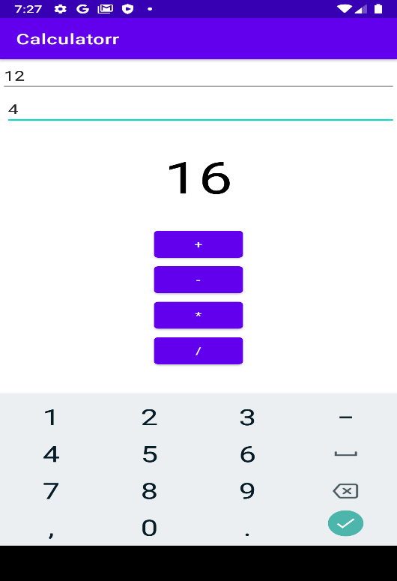

**Subtraction-**

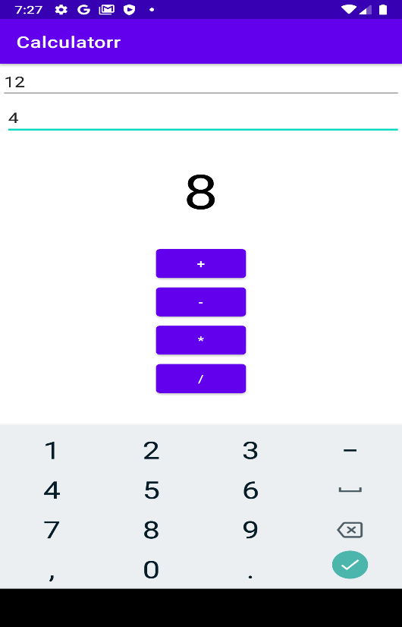

**Multiplication-**

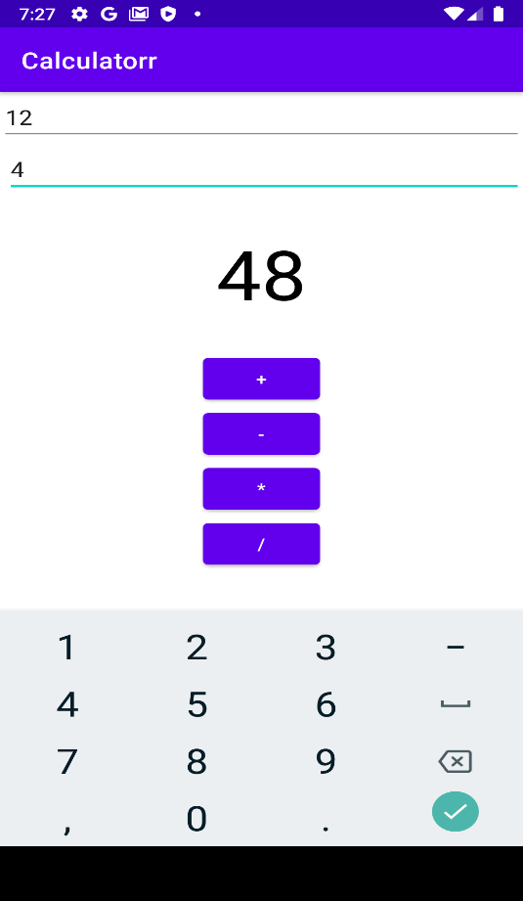

**Division-**

